The English Corner is Officially Opened
For the November 2014 issue we`ve prepared a story related to upcoming Thanksgiving Day, a national holiday celebrated primarily in the United States and Canada as a day of giving thanks for the blessing of the harvest and of the preceding year. In the United States it is celebrated on the fourth Thursday of November.
This story will provide an insight into Thanksgiving Day`s origins

The First Thanksgiving
by Nora Smith
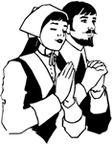
Nearly four hundred years ago, a great many of the people in England were very unhappy because their king would not let them pray to God as they liked. The king said they must use the same prayers that he did; and if they would not do this, they were often thrown into prison, or perhaps driven away from home.
"Let us go away from this country," said the unhappy Englishmen to each other; and so they left their homes, and went far off to a country called Holland. It was about this time that they began to call themselves "Pilgrims." Pilgrims, you know, are people who are always traveling to find something they love, or to find a land where they can be happier; and these English men and women were journeying, they said, "from place to place, toward heaven, their dearest country."
In Holland, the Pilgrims were quiet and happy for a while, but they were very poor; and when the children began to grow up, they were not like English children, but talked Dutch, like the little ones of Holland, and some grew naughty and did not want to go to church any more.
"This will never do," said the Pilgrim fathers and mothers; so after much talking and thinking and writing they made up their minds to come here to America. They hired two vessels, called the Mayflower and the Speedwell, to take them across the sea; but the Speedwell was not a strong ship, and the captain had to take her home again before she had gone very far.
The Mayflower went back, too. Part of the Speedwell's passengers were given to her, and then she started alone across the great ocean.
There were one hundred people on board - mothers and fathers, brothers and sisters and little children. They were very crowded; it was cold and uncomfortable; the sea was rough, and pitched the Mayflower about, and they were two months sailing over the water.
At last the Mayflower came in sight of land; but if the children had been thinking of grass and flowers and birds, they must have been very much disappointed, for the month was cold November, and there was nothing to be seen but rocks and sand and hard bare ground.
Some of the Pilgrim fathers, with brave Captain Myles Standish at their head, went on shore to see if they could find any houses or white people. But they only saw some Indians, who ran away from them, and found some Indian huts and some corn buried in holes in the ground. They went to and fro from the ship three times, till by and by they found a pretty place to live, where there were "fields and little running brooks."
Then at last all the tired Pilgrims landed from the ship on a spot now called Plymouth Rock, and the first house was begun on Christmas Day. But when I tell you how sick they were and how much they suffered that first winter, you will be very sad and sorry for them. The weather was cold, the snow fell fast and thick, the wind was icy, and the Pilgrim fathers had no one to help them cut down the trees and build their church and their houses.
The Pilgrim mothers helped all they could; but they were tired with the long journey, and cold, and hungry too, for no one had the right kind of food to eat, nor even enough of it.
So first one was taken sick, and then another, till half of them were in bed at the same time, Brave Myles Standish and the other soldiers nursed them as well as they knew how; but before spring came half of the people died and had gone at last to "heaven, their dearest country."
But by and by the sun shone more brightly, the snow melted, the leaves began to grow, and sweet spring had come again.
Some friendly Indians had visited the Pilgrims during the winter, and Captain Myles Standish, with several of his men, had returned the visit.
One of the kind Indians was called Squanto, and he came to stay with the Pilgrims, and showed them how to plant their corn
When the summer came and the days were long and bright, the Pilgrim children were very happy, and they thought Plymouth a lovely place indeed. All kinds of beautiful wild flowers grew at their doors, there were hundreds of birds and butterflies, and the great pine woods were always cool and shady when the sun was too bright.
When it was autumn the fathers gathered the barley and wheat and corn that they had planted, and found that it had grown so well that they would have quite enough for the long winter that was coming.
"Let us thank God for it all," they said. "It is He who has made the sun shine and the rain fall and the corn grow." So they thanked God in their homes and in their little church; the fathers and the mothers and the children thanked Him.
"Then," said the Pilgrim mothers, "let us have a great Thanksgiving party, and invite the friendly Indians, and all rejoice together."
So they had the first Thanksgiving party, and a grand one it was! Four men went out shooting one whole day, and brought back so many wild ducks and geese and great wild turkeys that there was enough for almost a week. There was deer meat also, of course, for there were plenty of fine deer in the forest. Then the Pilgrim mothers made the corn and wheat into bread and cakes, and they had fish and clams from the sea besides.
The friendly Indians all came with their chief Massasoit. They brought five deer with them, that they gave to the Pilgrims; and they must have liked the party very much, for they stayed three days.
They were dressed in deerskins, and some of them had the furry coat of a wild cat hanging on their arms. Their long black hair fell loose on their shoulders, and was trimmed with feathers or fox-tails. They had their faces painted in all kinds of strange ways, some with black stripes as broad as your finger all up and down them. But whatever they wore, it was their very best, and they had put it on for the Thanksgiving party.
Each meal, before they ate anything, the Pilgrims and the Indians thanked God together for all his goodness.
The Pilgrim mothers and fathers had been sick and sad many times since they landed from the Mayflower; they had worked very hard, often had not had enough to eat, and were mournful indeed when their friends died and left them. But now they tried to forget all this, and think only of how good God had been to them; and so they all were happy together at the first Thanksgiving party.
All this happened nearly four hundred years ago, and ever since that time Thanksgiving has been kept in our country.

Thanksgiving today

Thanksgiving is one of the most important holidays in the United States of America. Thanksgiving is celebrated on the fourth Thursday in November.
Americans celebrate Thanksgiving by eating a big dinner similar to what the Pilgrims ate almost four hundred years ago.
Americans usually join their extended family for Thanksgiving dinner. Grandparents, aunts, uncles, cousins, etc.

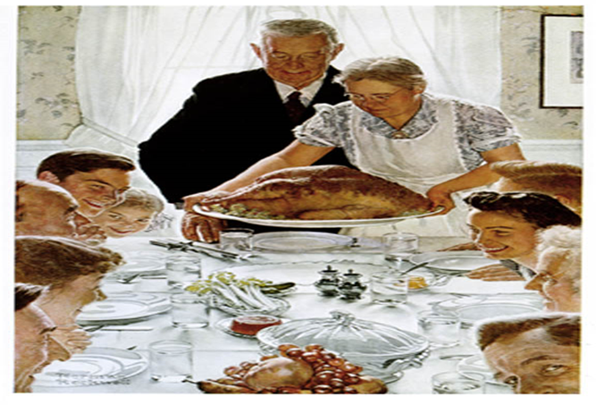

- Thanksgiving Dinner
Stuffed turkey
Roasted turkey is the most important part of Thanksgiving dinner, just as Turkey was important for the Pilgrims.
The turkey is usually stuffed with bread, vegetables, and spices. This stuffing is served separately.
The fat from the turkey is used to make gravy
Gravy
Mashed potatoes are a popular side dish on Thanksgiving. Mashed potatoes are served with gravy.
Sweet potatoes are also popular. In American families, we make candied sweet potatoes with butter and molasses.
Cranberry sauce
Families like to make cranberry sauce, which is a sweet and sour sauce made from cranberries grown in Massachusetts, where the Pilgrims settled.
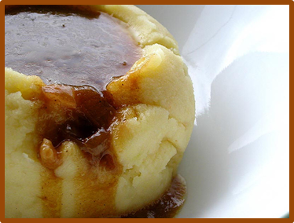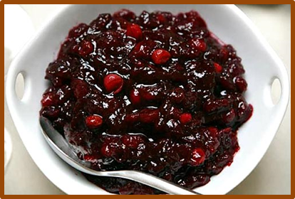

- Dessert
Pumpkin pie
Families eat pumpkin pie just like the Pilgrims and Wampanoag ate pumpkins (squash). They usually make pumpkin pie the day before Thanksgiving because it takes a long time.
They also eat apple pie. Both pumpkin pie and apple pie can be served with vanilla ice cream or whipped cream.

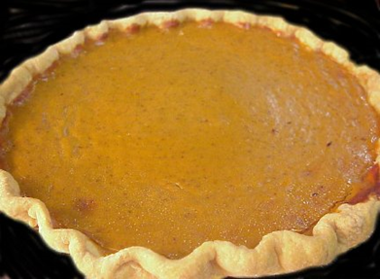

- Thanksgiving and Football
Most professional football games are played on Sundays, but Thanksgiving is an exception: three professional football games are played every Thanksgiving. The Detroit Lions always host an afternoon game. The Dallas Cowboys always host an evening game. The third game, a night game, does not have a regular host.

